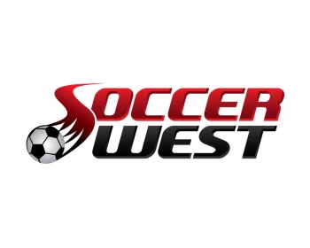
TEAM ORDERING OVERVIEW

- No need to log in anymore! There will be no notification email outside of one from the club that your player is loaded and uniform ready to order. We encourage everyone to create an account once you order for tracking purposes. However, now as well as throughout the year, Mom, Dad, family members, etc will be able to order any time without having to have one account tied to the player.
- Your club will provide us a spreadsheet with your player upload for each team. Once your team is uploaded, typically 24 hours or less, your team/club will inform you that you may order.
- You can also check the website for updates.
- Shipping – Any orders over $100 receive FREE SHIPPING. This includes team uniform orders.
PROCESS
- Go to www.soccerwest.comOn the main page there are multiple headers listing our categories. Hold your curser over the category“CLUBS”
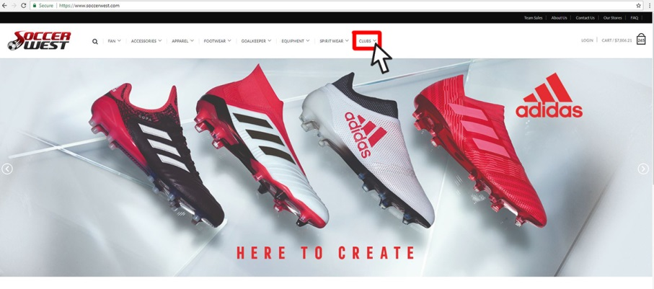
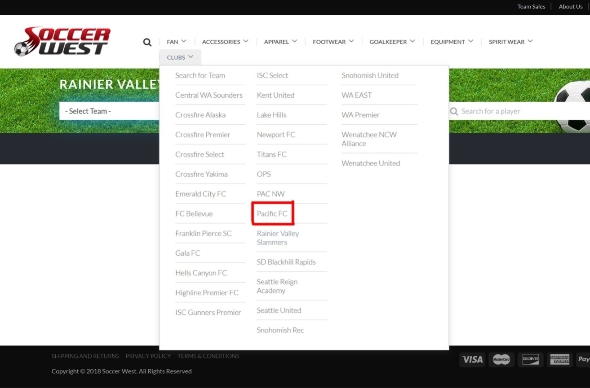
- Select your“Club Name” in drop down box.

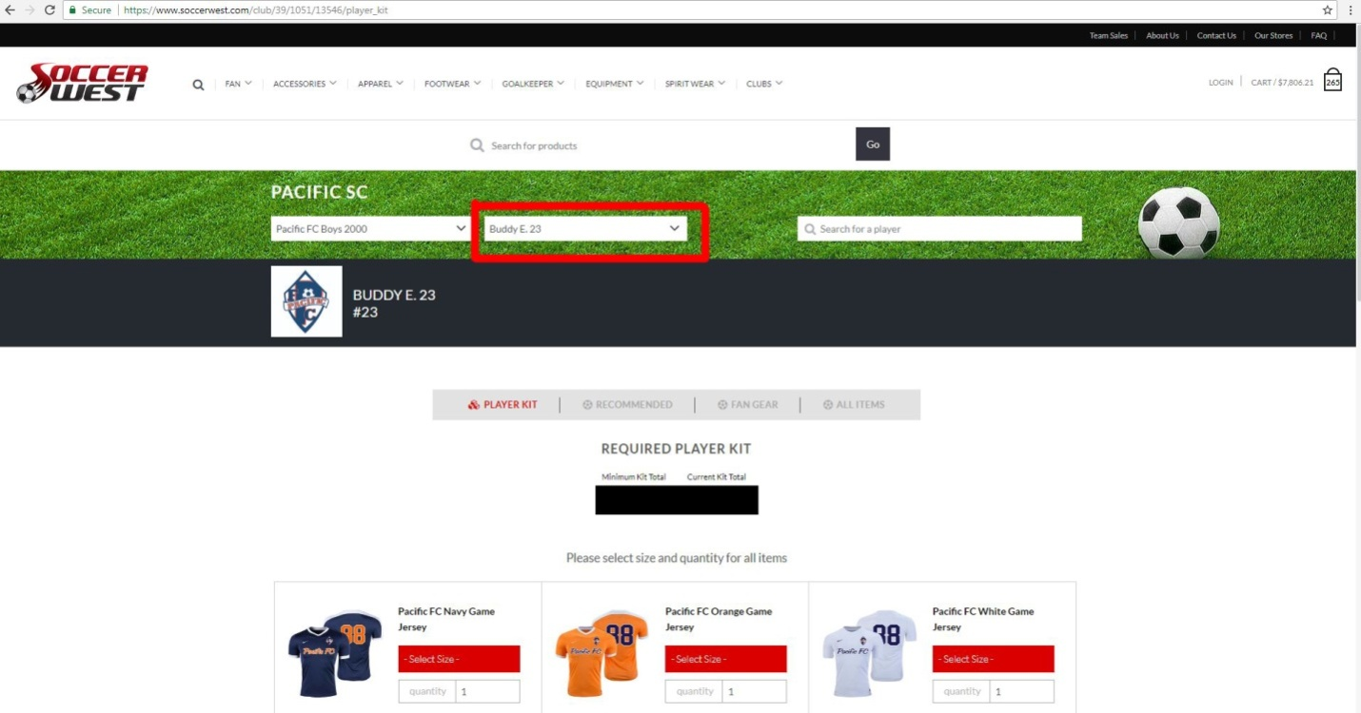
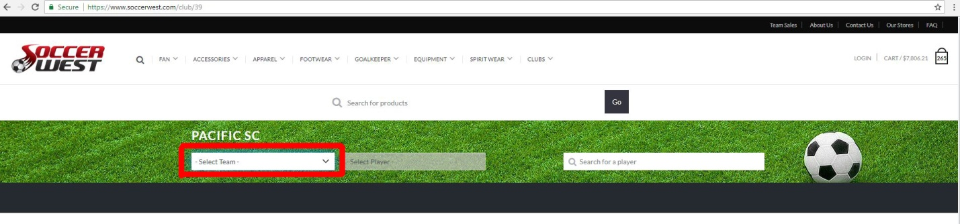
- Go to your player birth/play year and select your player. Players are listed first name and last initial and are sorted numerically. Select your player.
- You will then need to buy any required items before proceeding to any other type of ordering.
  - Numbers are pre-loaded. You cannot change the number nor do you need to input.
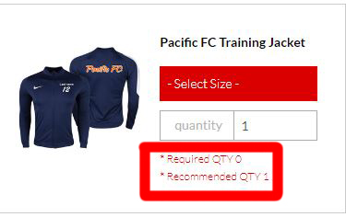
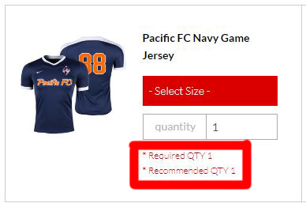
  - Item quantities are already set to the recommended number. You need to carefully select your size and quantity. We often “recommend” purchasing more than 1 sock or training item and adding a rain jacket. Again, you only have to purchase what is “required”. This is very clearly stated by each item.
  - You can add more than one unit of any item on the required page and will receive the special kit pricing. You will see your kit price move up or down respectively if you change your units on required items to more than 1 or add a recommended item.
  - The “add your kit” button will turn red once you select a size and have a quantity of 1 under each “required” item.
  - Anyone who was listed as a keeper will have a special keeper kit.
  - Special Note – the preloaded number showing on an item’s image is only for appearance. Your player will receive their specific number on each customized item they order.
- After you add your kit, the site will direct you to fan gear items. You can check out anytime or keep shopping around for fan gear, recommended or incremental items, shoes, guards, balls, and/or anything we sell online.

- IMPORTANT – 10% DISCOUNT!
  - On the front of your page is a promo code for a 10% discount. This discount should be used at checkout. It is not applicable for any required kit items.
  - It IS good for all other items on our website including fan gear, recommended items, shoes, etc. Discount will be reflected once you enter your code prior to checkout.
  - The promo code and 10% discount is also good at any one of our six Soccer West stores.
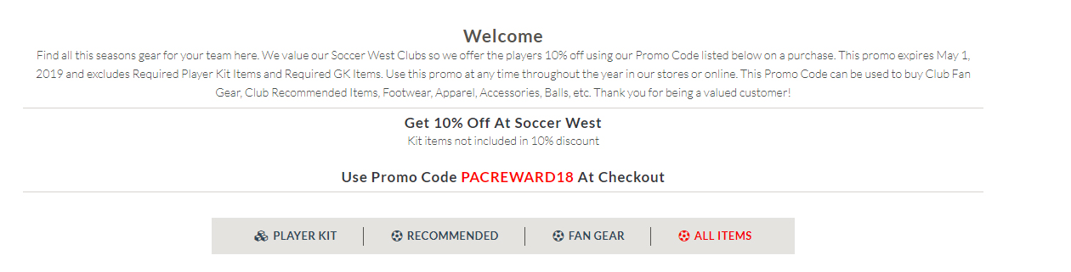

- Sizing
  - We strongly encourage players and families to attend the uniform try-on sessions created by each club.
  - At the bottom of the page, there is also a sizing link for parents to review

  - Please see our full return policy, but it is important to attend try-on sessions to ensure your player selects the right sizes. There are no returns or refunds on any customized item.

